Mauritius

## Political Stability Estimate Data

The data set shows the political stability estimate of the country each year.

## # A tibble: 19 x 5  
## country iso3c date stability stabilityCategory4  
## <chr> <chr> <dbl> <dbl> <chr>   
## 1 Mauritius MUS 1996 1.09 highly stable   
## 2 Mauritius MUS 1998 0.967 moderately stable   
## 3 Mauritius MUS 2000 0.757 moderately stable   
## 4 Mauritius MUS 2002 1.12 highly stable   
## 5 Mauritius MUS 2003 1.01 highly stable   
## 6 Mauritius MUS 2004 0.975 moderately stable   
## 7 Mauritius MUS 2005 1.03 highly stable   
## 8 Mauritius MUS 2006 0.780 moderately stable   
## 9 Mauritius MUS 2007 0.879 moderately stable   
## 10 Mauritius MUS 2008 0.890 moderately stable   
## 11 Mauritius MUS 2009 0.706 moderately stable   
## 12 Mauritius MUS 2010 0.640 moderately stable   
## 13 Mauritius MUS 2011 0.946 moderately stable   
## 14 Mauritius MUS 2012 0.971 moderately stable   
## 15 Mauritius MUS 2013 0.945 moderately stable   
## 16 Mauritius MUS 2014 0.668 moderately stable   
## 17 Mauritius MUS 2015 0.999 moderately stable   
## 18 Mauritius MUS 2016 1.01 highly stable   
## 19 Mauritius MUS 2017 0.995 moderately stable

## Political Stability Estimate Plot

The plot shows the trends of stabilization and destabilization for the each country.

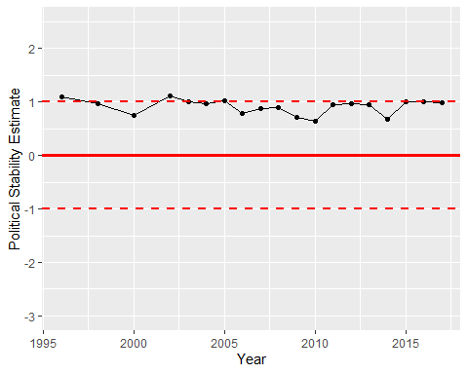

Political Stability Trend